**Demo: Launch and Connect to EC2 Ubuntu Instance**

Goto EC2 Dashboard and in the left pane click on Instances.

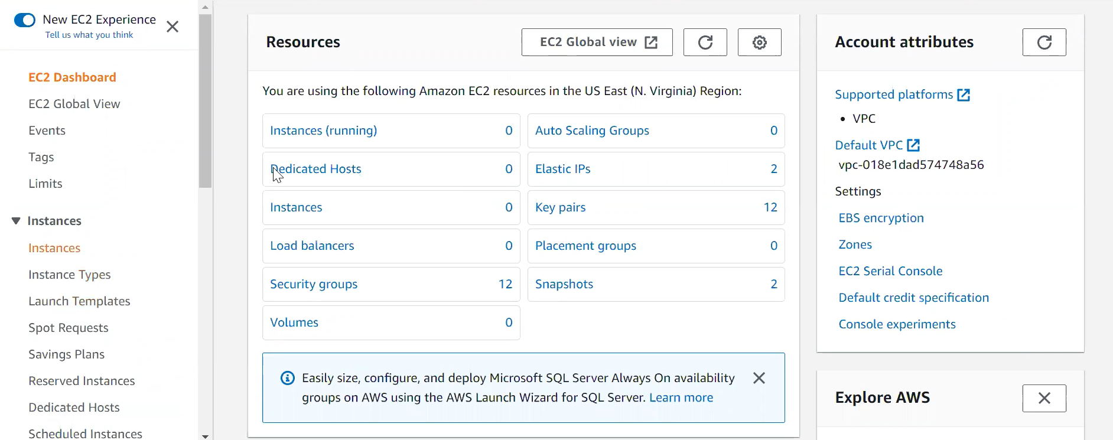

Now provide a name to your instance.

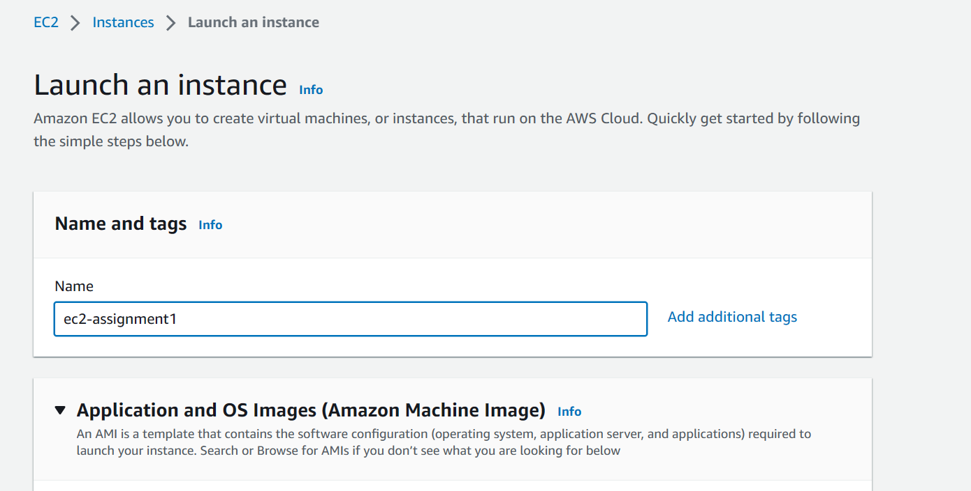

Select the Ubuntu AMI.

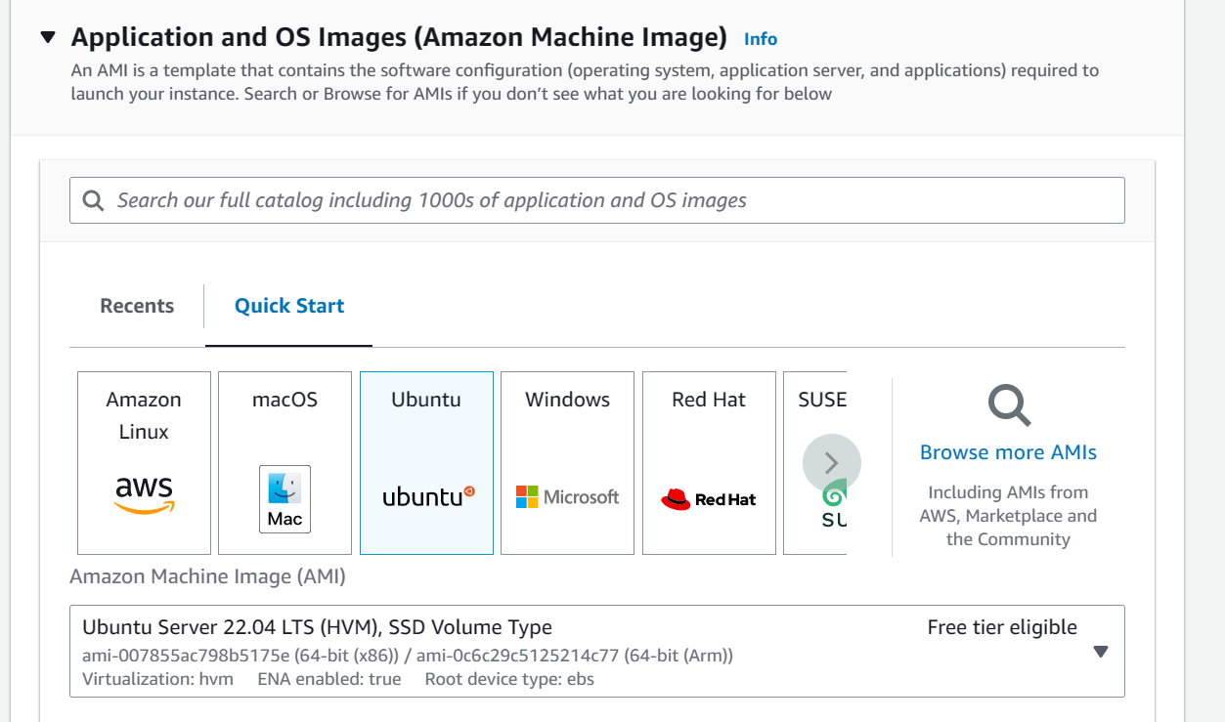

Choose Instance Type as **t2.micro** as it is the instance type which comes under **Free Tier**.

Now, select one of the existing key pairs, as it will allow us to connect to our instance using an ssh client such as PuTTy later.

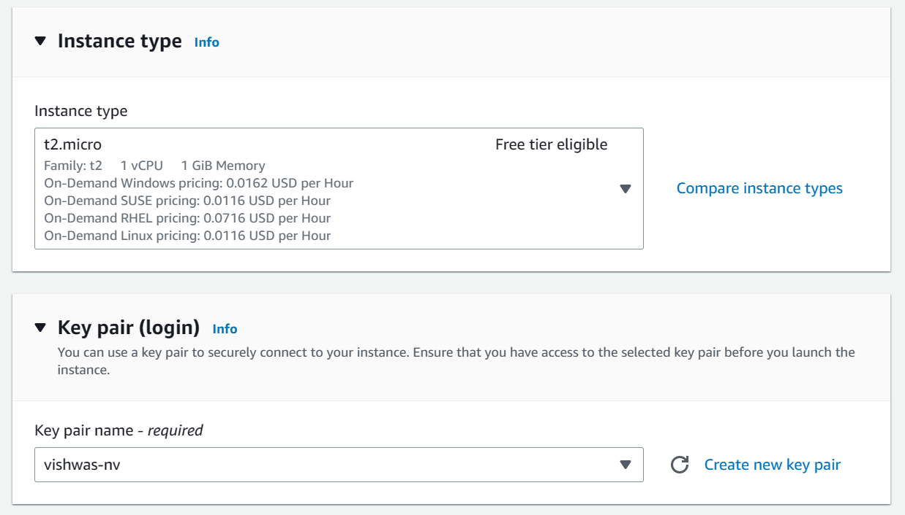

In case you are not having any existing key pairs, you can also create a new key pair by clicking on **Create new key pair** option.

Provide a name and create a key with **RSA** and **.pem** extension.

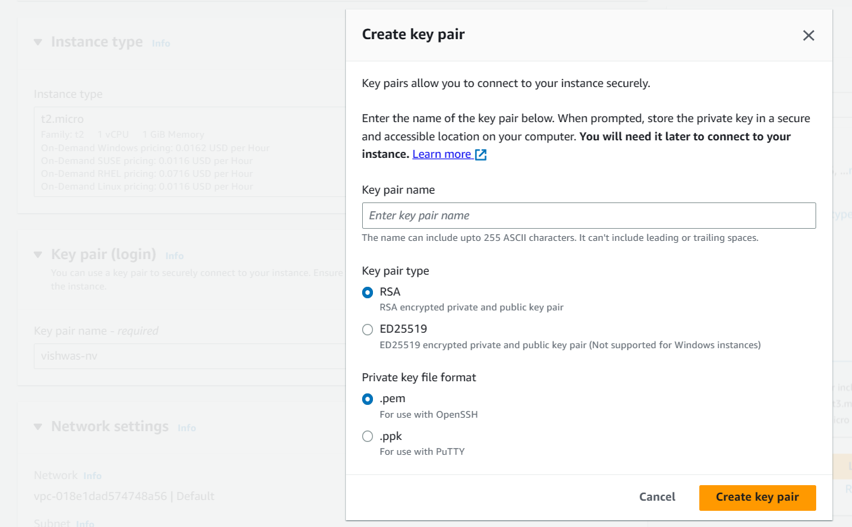

Once done, now in network settings, create a new security group with ssh and http protocols allowed.

Note: You can also use existing security groups.

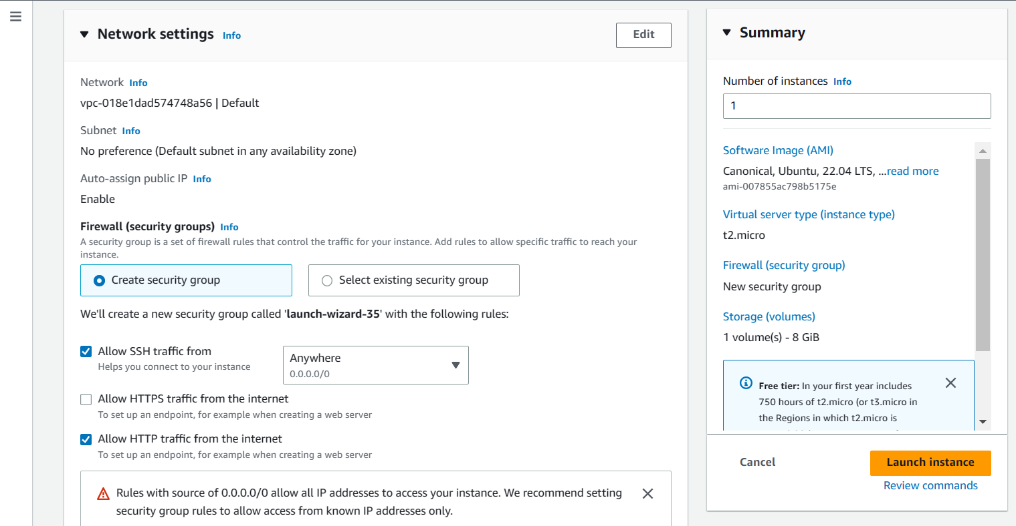

Configure the storage, 8gb storage is sufficient for our purpose.

Now, click on **Launch Instance.**

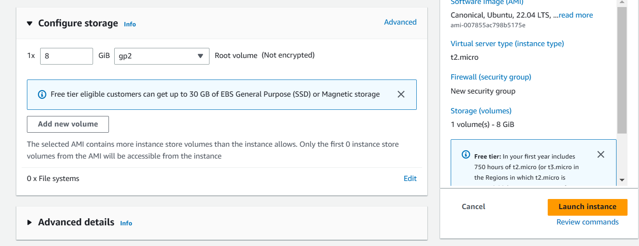

After launching it successfully, you can go back to instances.

After waiting for a few seconds, the instance will be in running state and we can login to it.



To login, now open Puttygen in your system.

You can download Putty **64-bit x86: putty-64bit-0.78-installer.msi** from here: <https://www.chiark.greenend.org.uk/~sgtatham/putty/latest.html>

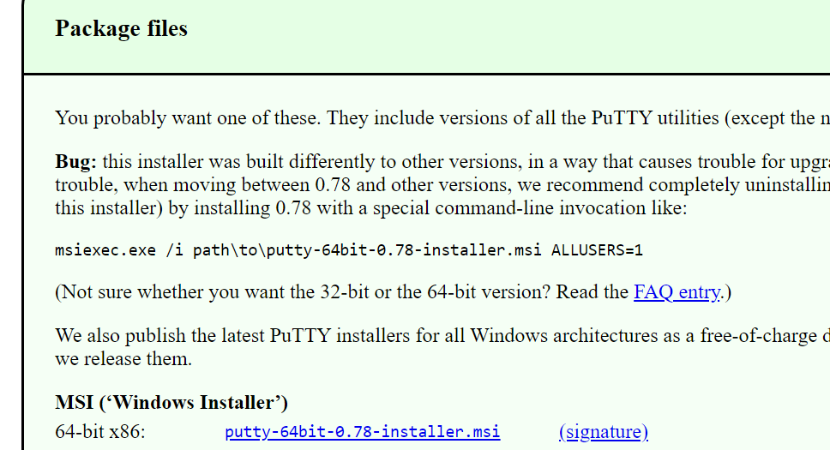

After Downloading, you need to install it by all default configurations.

After Installation is done, just search putty in your windows search bar.

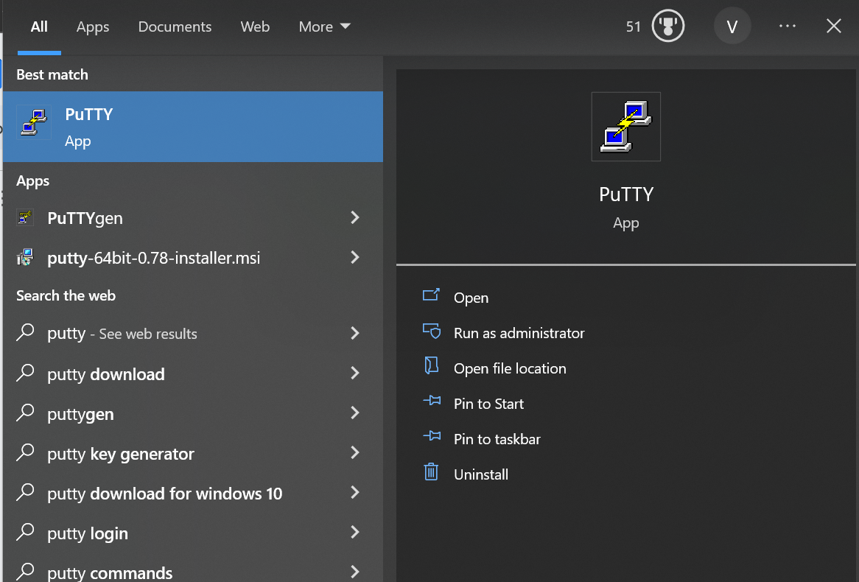

Open Puttygen.

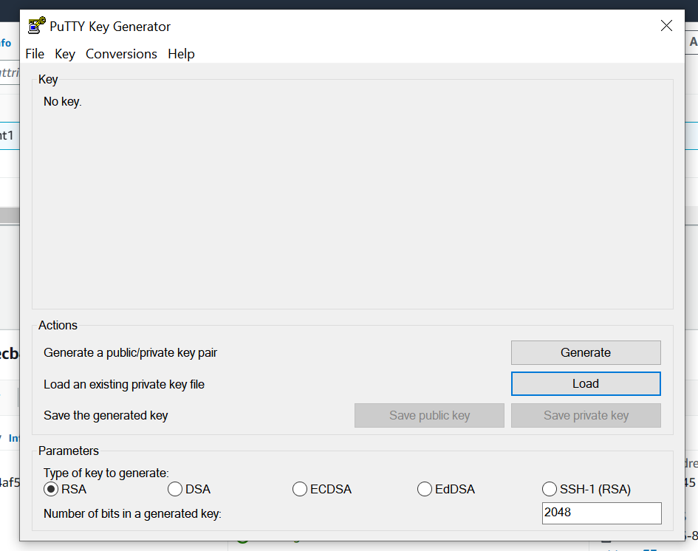

Click on Load:

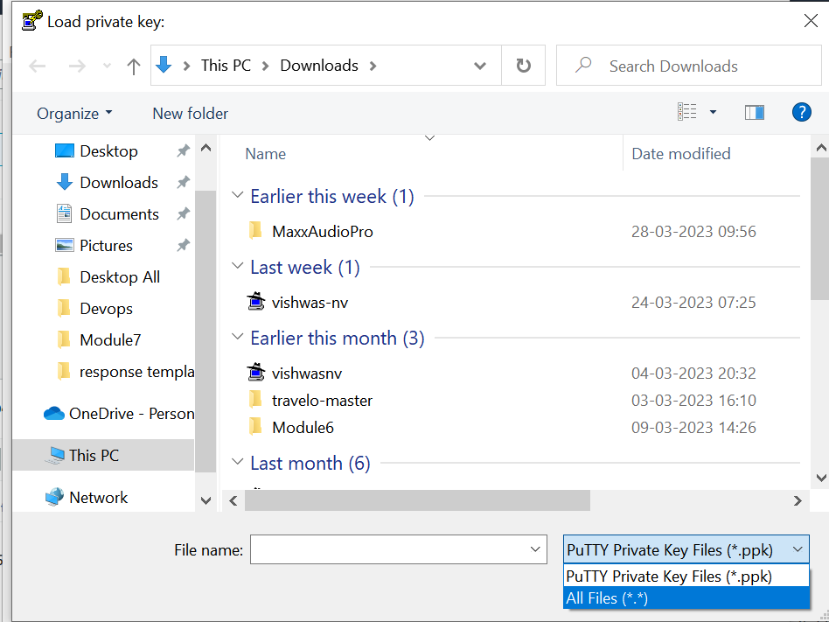

Select your .pem key

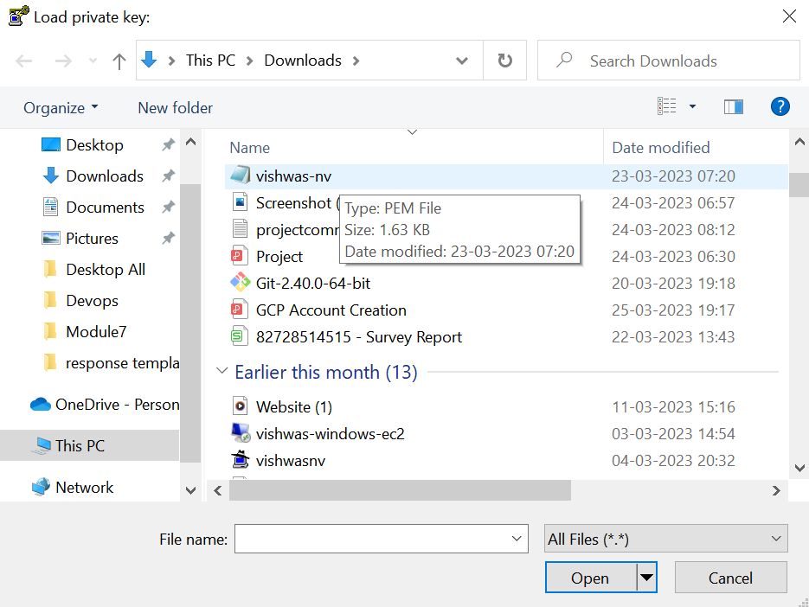

Key is successfully imported.

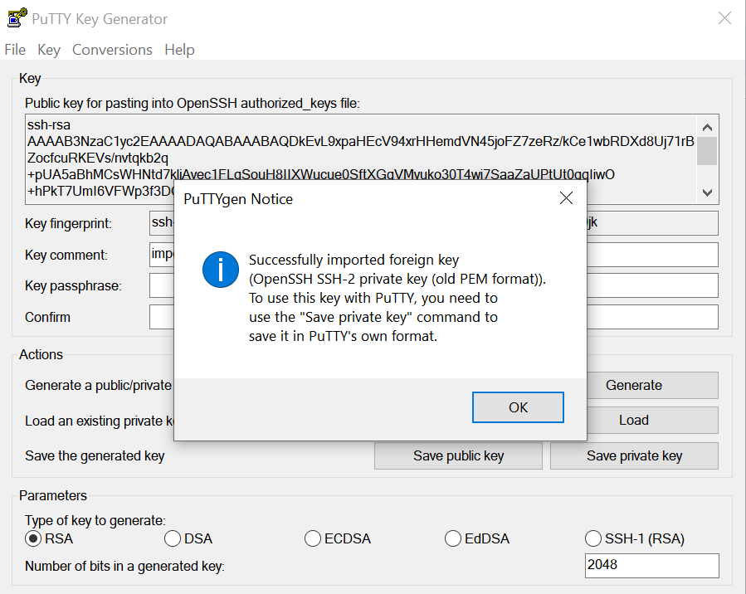

Now, click on save private key.

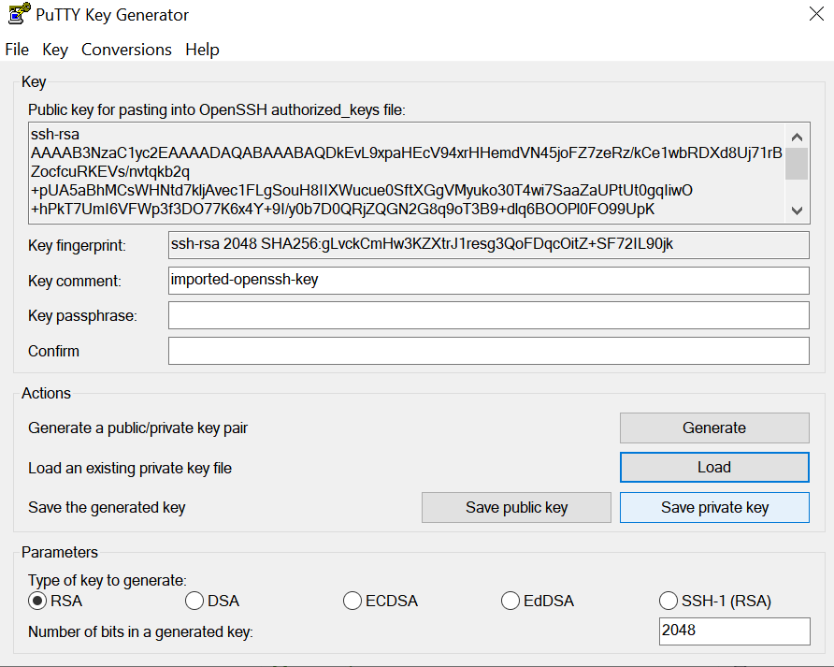

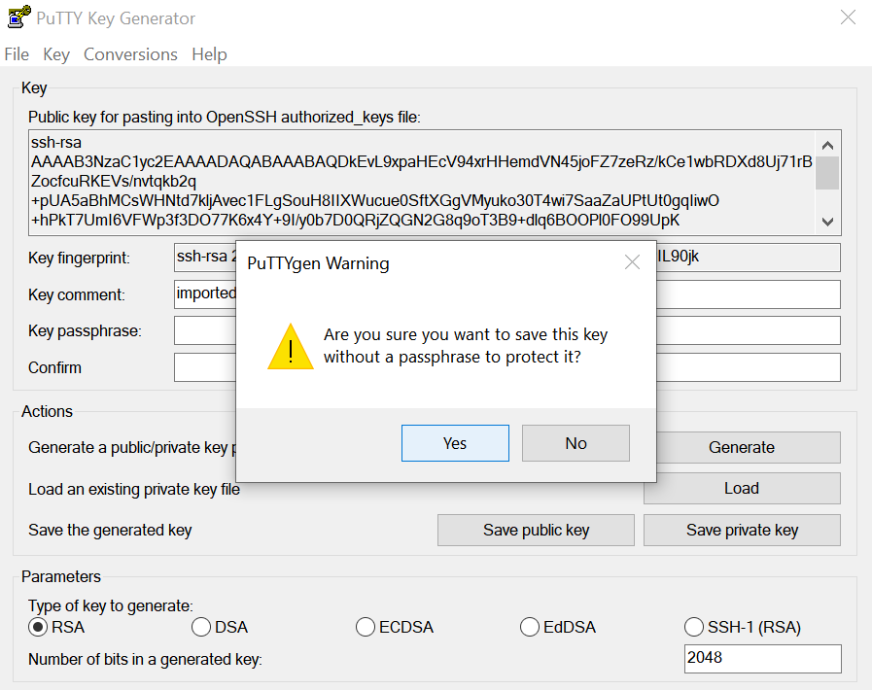

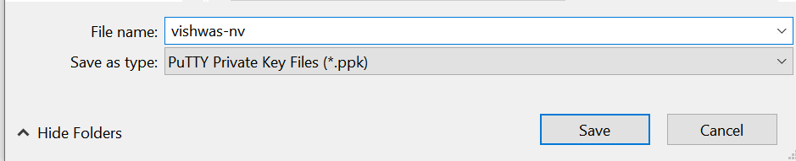

Once saved, go back to Ec2 console and copy public ip of your instance.

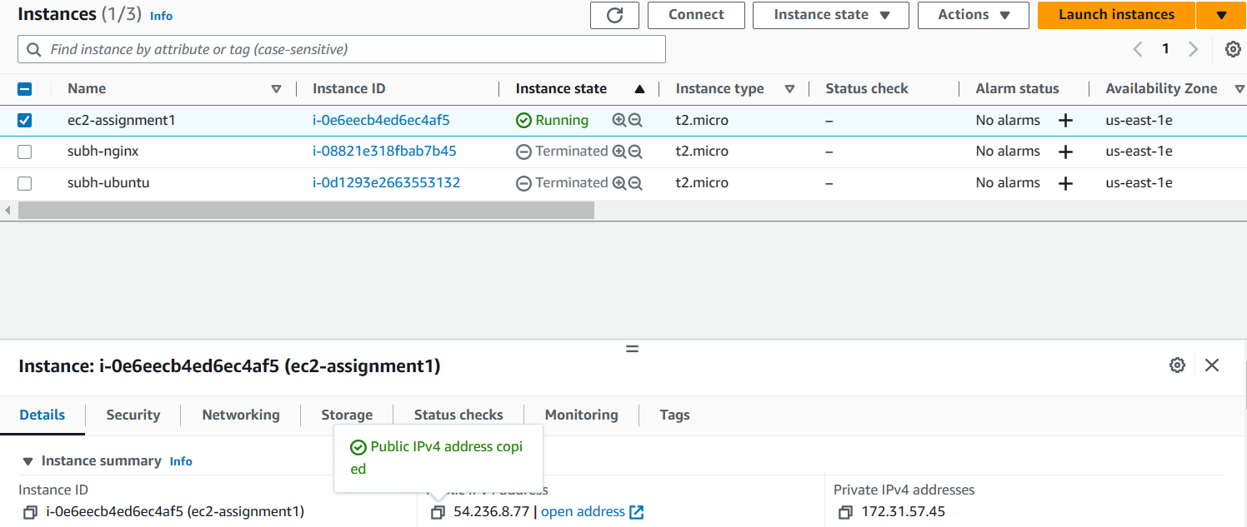

Paste the public ip in host name in Putty.

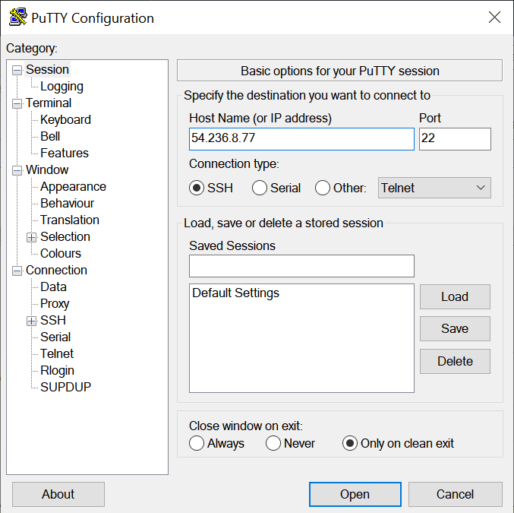

Now in left pane, go to ssh >> Auth >> Credentials:

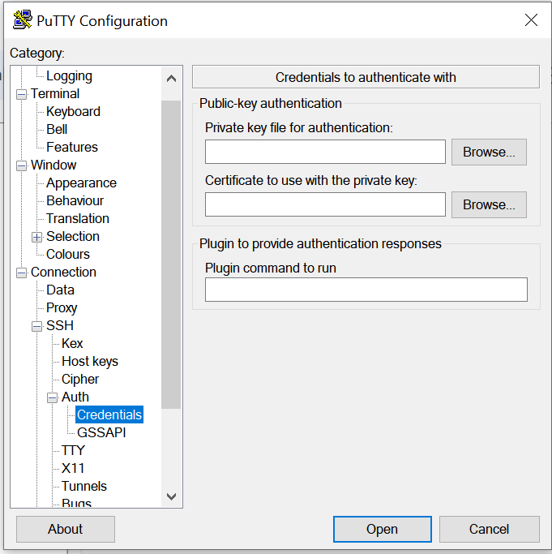

Click on Browse, select the ppk key and click on open.

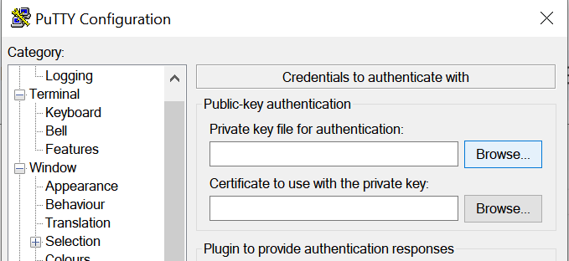

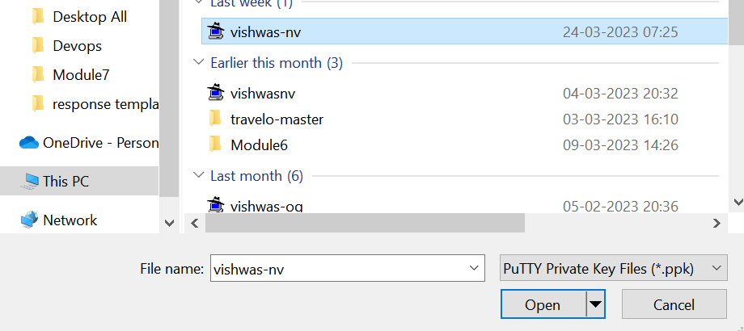

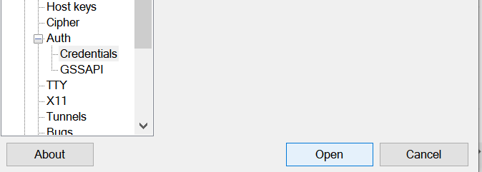

Click on Accept.

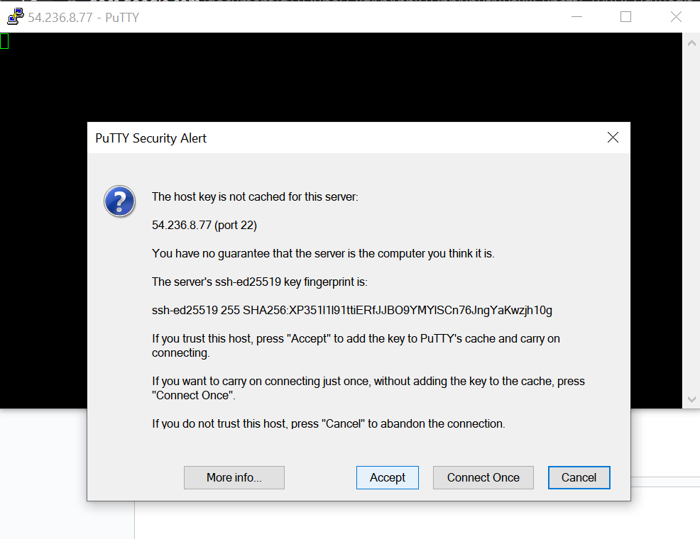

Provide the username as **ubuntu** as it is an ubuntu instance.

For Amazon linux and Redhat instances this username will be **ec2-user.**

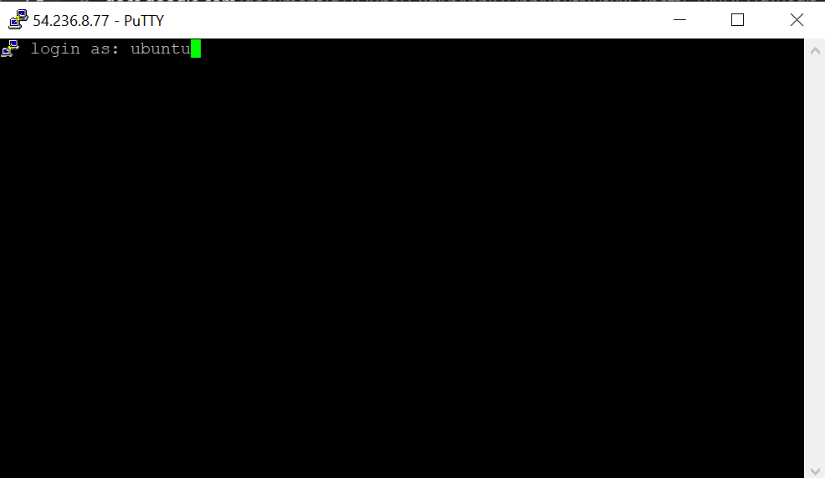

You are now successfully connected.

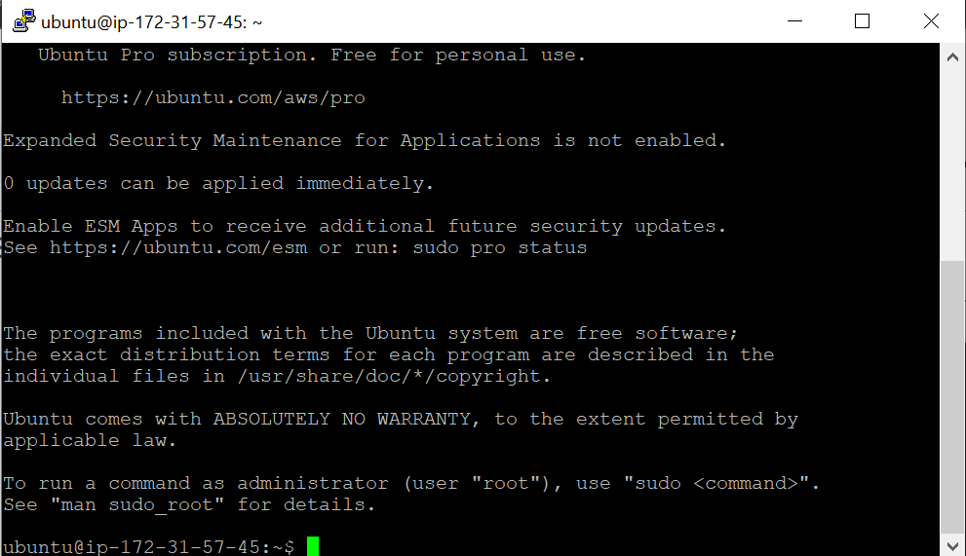

Now run the following command as shown in pictures below to update the system and install nginx webserver on it.

Commands:

sudo apt-get update

sudo apt-get install nginx -y

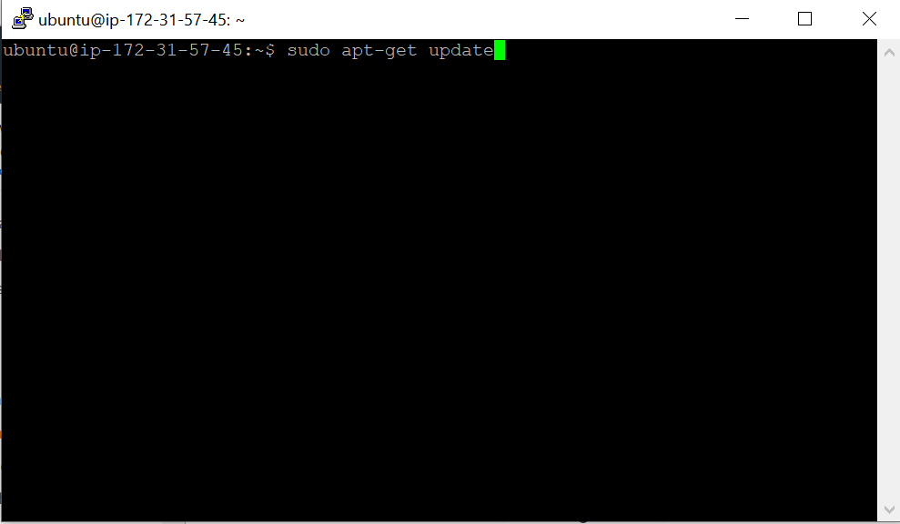

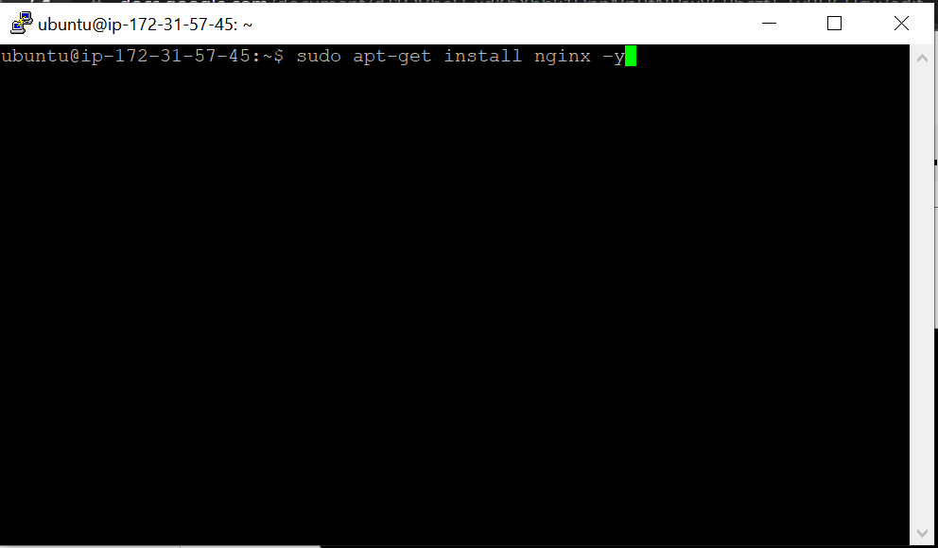

Now paste the public ip on the browser, you will be able to see the web server running.

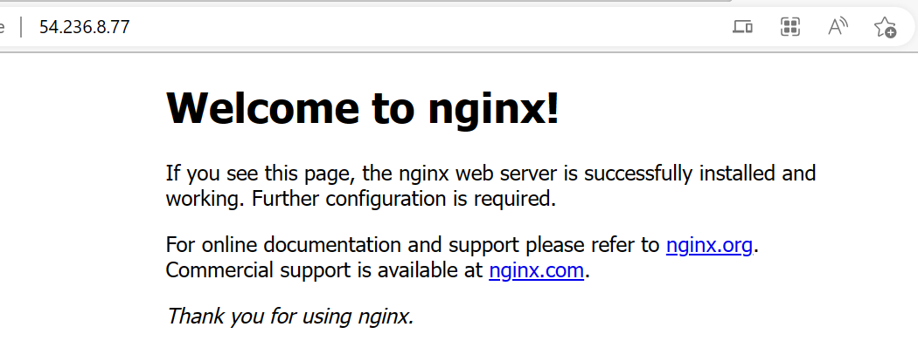

**Change the default website with a hello world page**

Use the following command in sequence to change the default page to hello world page.

cd /var/www/html

ls

sudo su

sudo rm index.-nginx-debian.html

echo “hello world”>>index.html

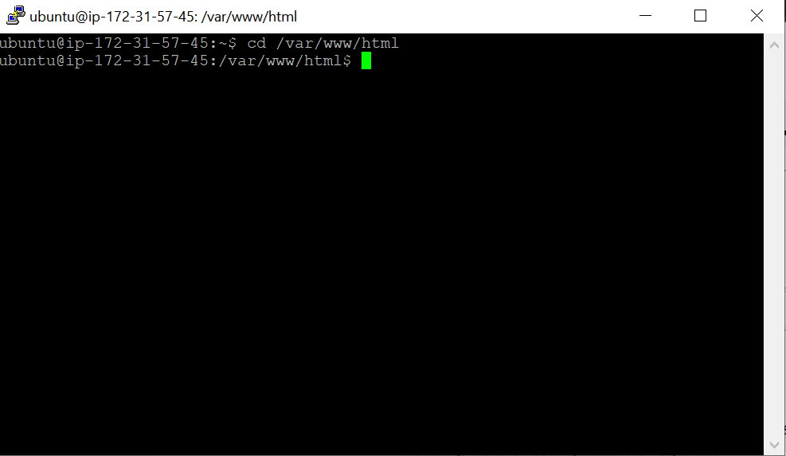

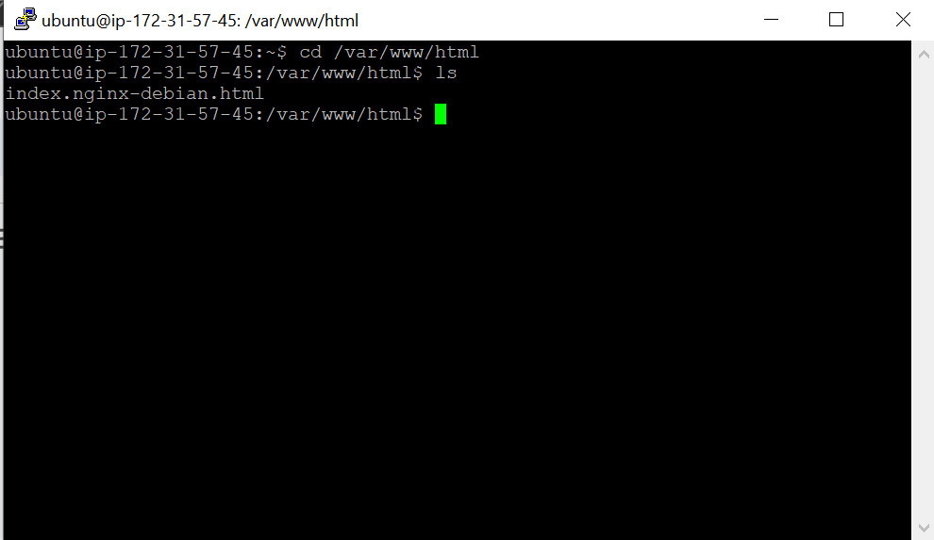

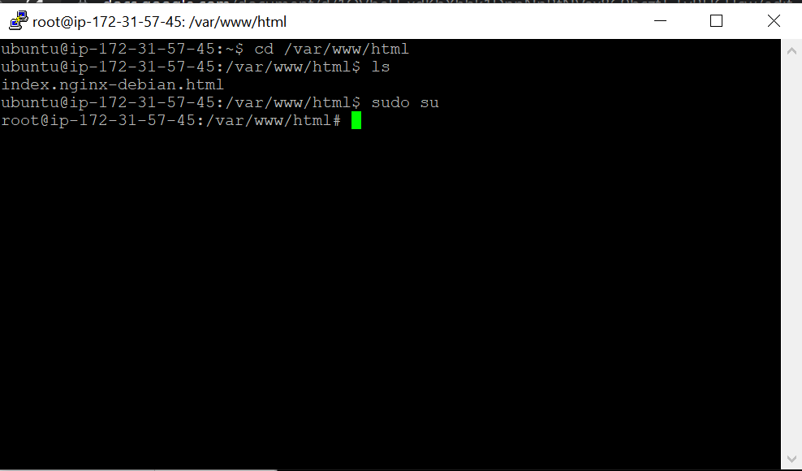

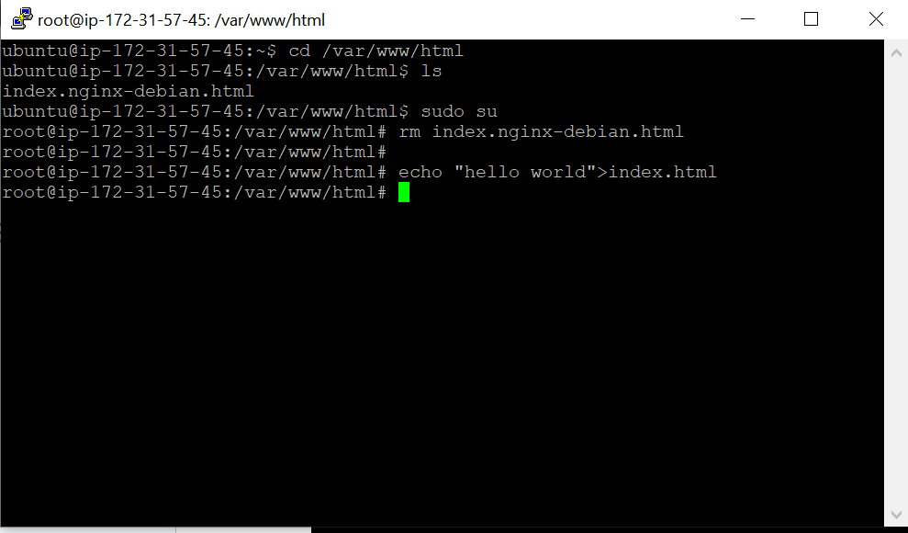

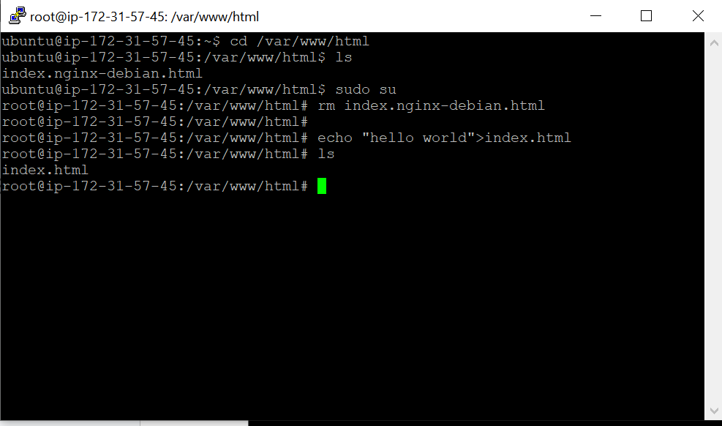

Now, refresh the webpage, you will be able to see the hello world page.

